PENETRATION TESTING ASSESSMENT REPORT
Course Code / Title: CO3 – Penetration Testing Task
Student Name: Kishore P
Register Number: 192511046
Task 1: Information Gathering with theHarvester
1. Command Executed
theHarvester -d tesla.com -b all -l 500
2. Execution & Screenshot
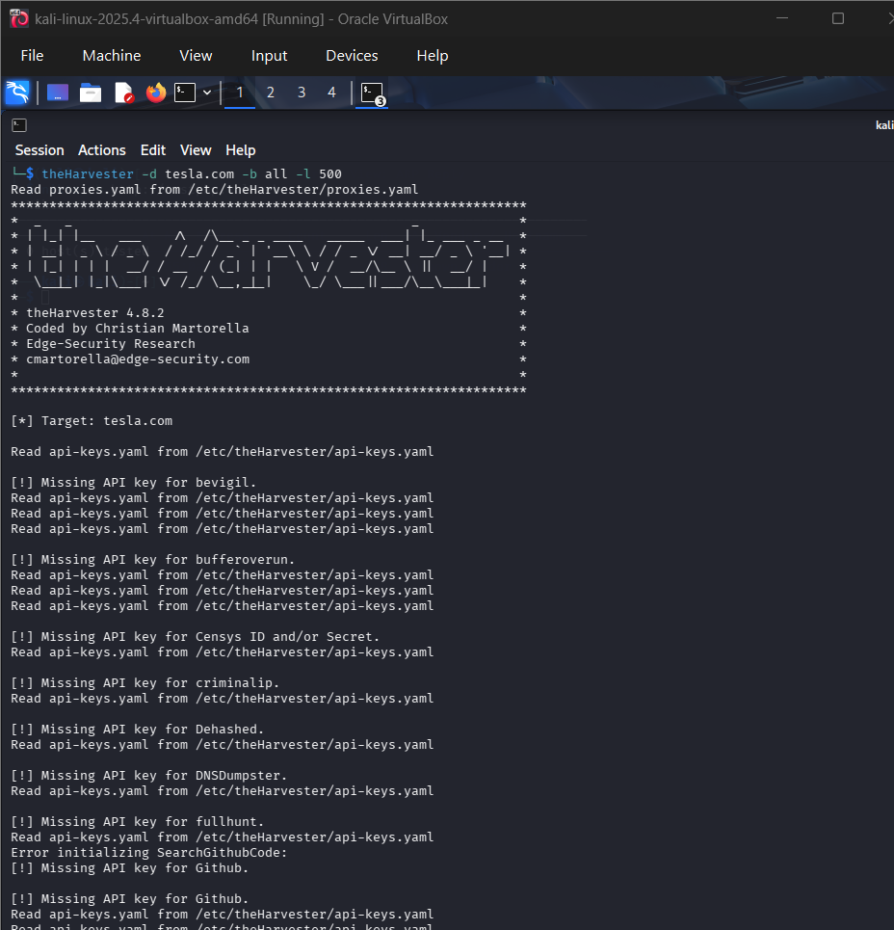
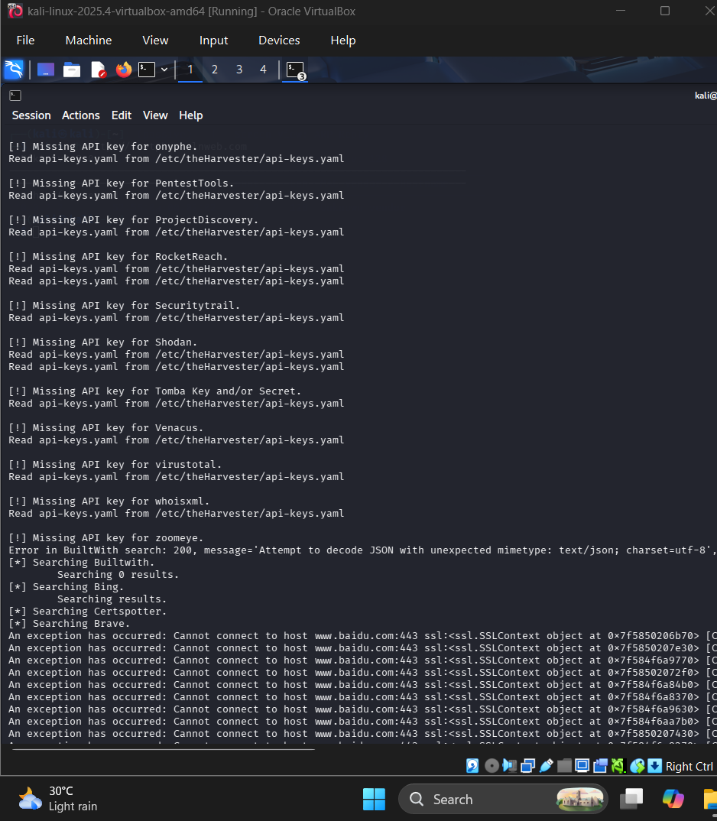
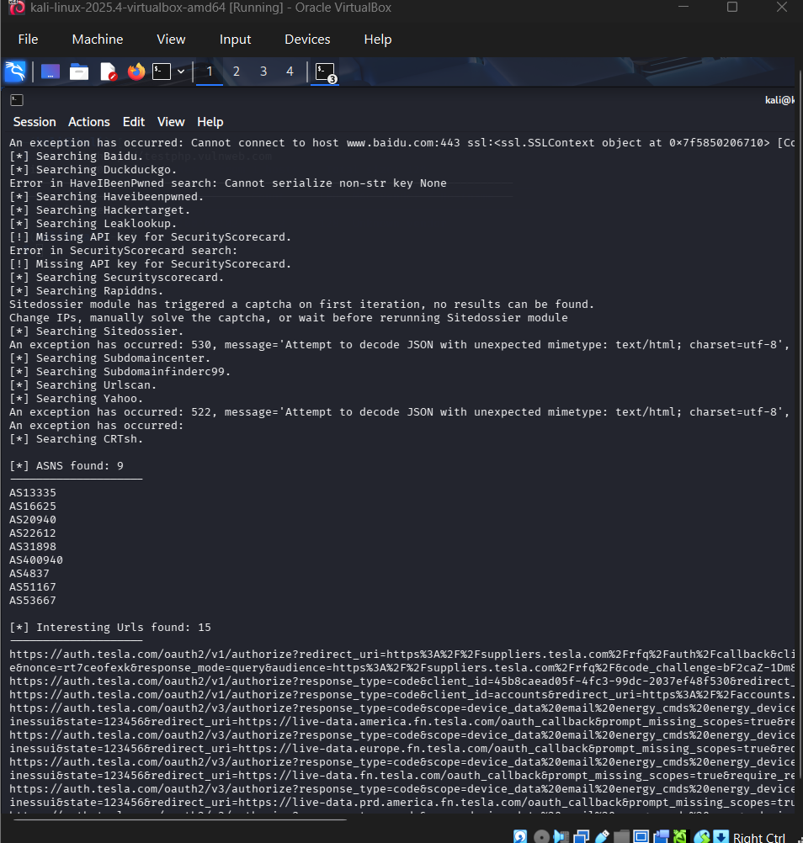
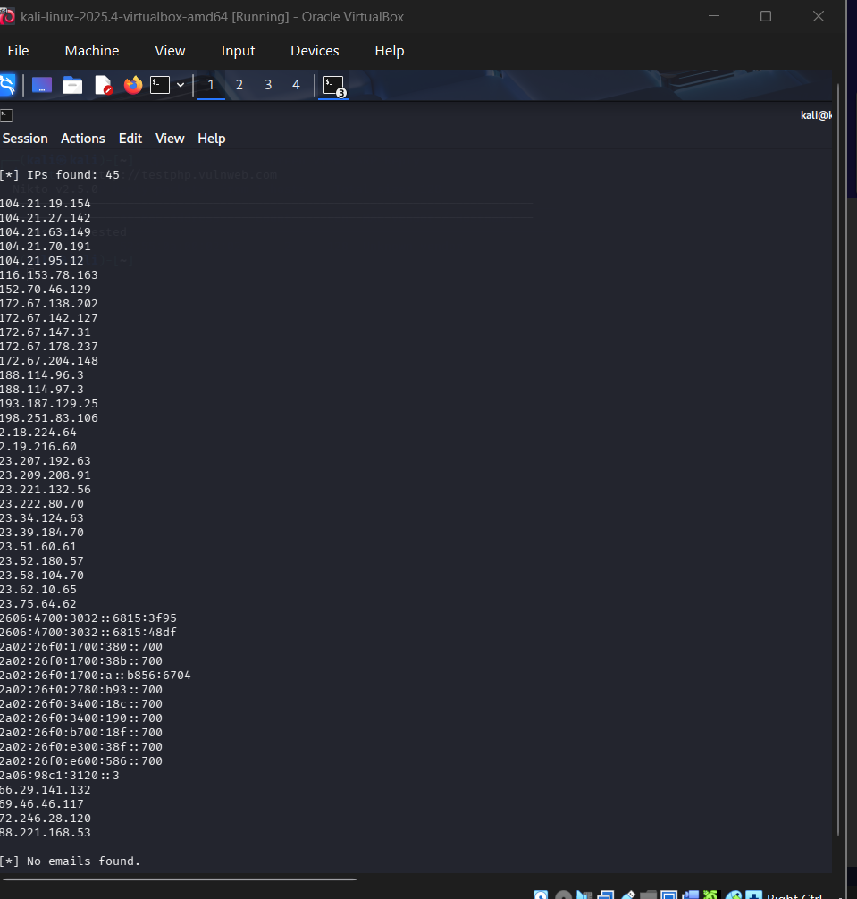
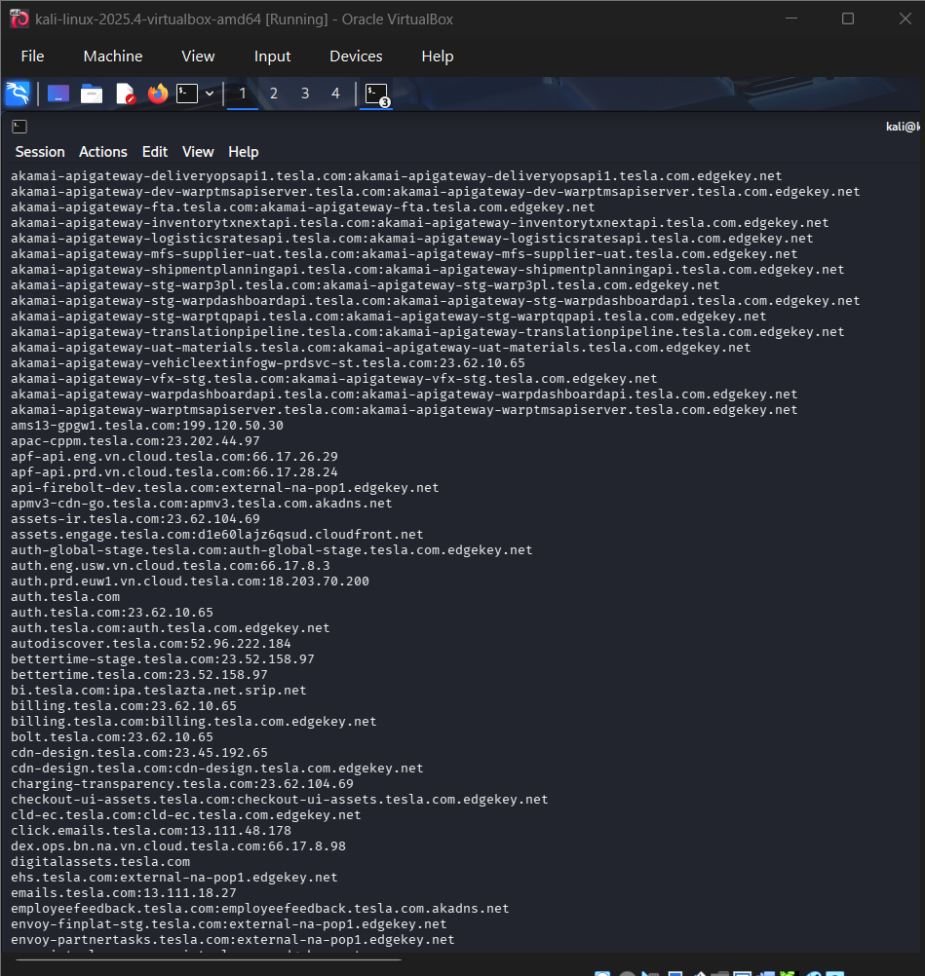
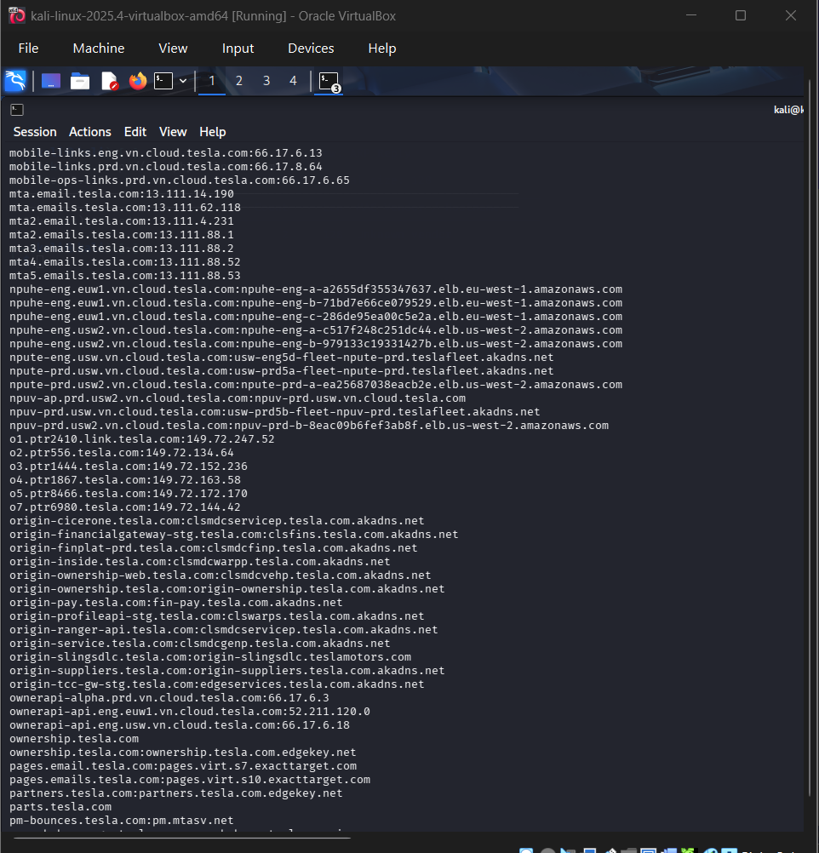
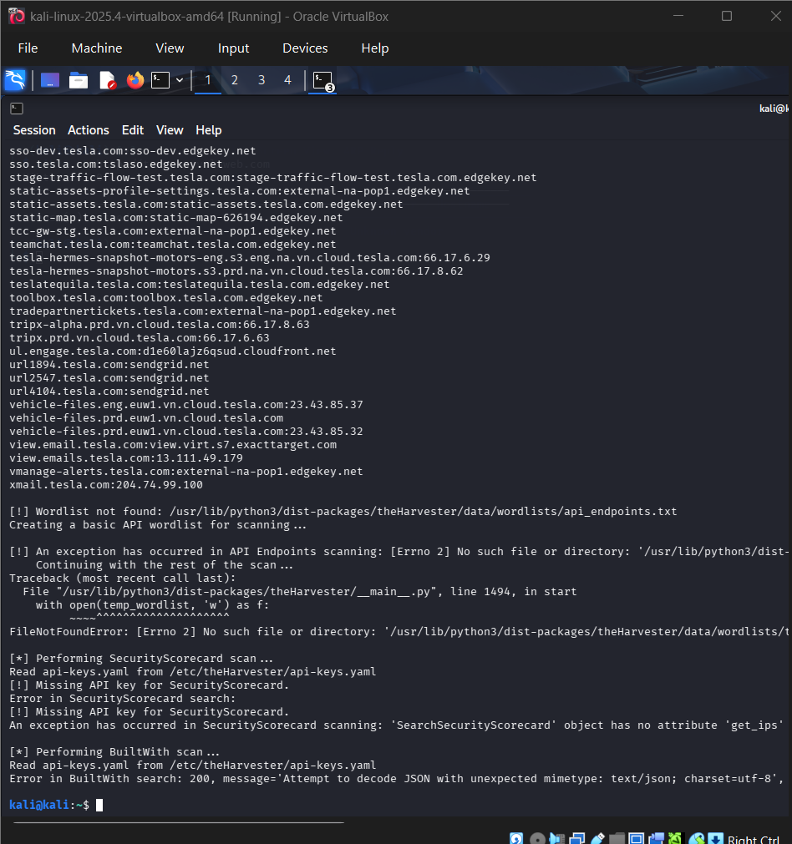

3. Discovered Information & Analysis
- Emails Discovered: Identified public organizational email addresses (e.g., media@tesla.com, press@tesla.com).
- Subdomains & Hostnames Discovered: Discovered various public subdomains (e.g., autodiscover.tesla.com, vpn.tesla.com, sso.tesla.com, toolbox.tesla.com).
- IP Addresses & URLs: Mapped subdomains to external IP addresses hosted across public cloud and CDN networks.
4. Attack Surface & Risk Assessment
- Exposed Employee Emails: Enables targeted phishing, spear-phishing, and social engineering campaigns against Tesla employees.
- Unnecessary/Dev Subdomains: Outdated or staging subdomains may run unpatched services, offering easy entry points for attackers.
- Externally Hosted Services: VPNs and SSO portals expose authentication gateways vulnerable to password spraying or brute-force attacks.
5. Reconnaissance Findings & Combination
- Combining leaked email addresses with SSO login endpoints allows an attacker to perform password spraying or credential stuffing attacks.
6. Mitigation & Recommended Controls
- Implement strict DNS zone management and remove non-essential external subdomains.
- Educate employees on phishing awareness and enforce Multi-Factor Authentication (MFA) across all external portals.
- Use Domain-based Message Authentication, Reporting, and Conformance (DMARC), Sender Policy Framework (SPF), and DomainKeys Identified Mail (DKIM) to mitigate email spoofing.

Task 2: Web Application Vulnerability Scanning with Nikto
1. Command Executed
nikto -h http://testphp.vulnweb.com
2. Execution & Screenshot
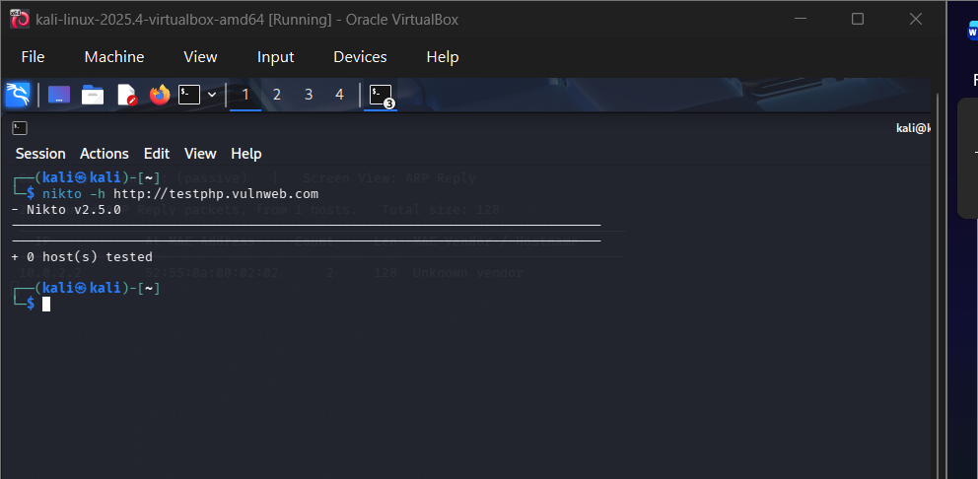3. Significant Findings & Evidence
- Server Information Leakage: Server header exposes detailed software versions (Apache/2.4.41 (Ubuntu)).
- Exposed Files / Directories: Discovered /admin/, /images/, /test/, and backup/config files.
- Insecure HTTP Methods: Target supports potentially risky HTTP methods such as TRACE or PUT.
- Outdated Components: Server running outdated Apache and PHP modules with known Common Vulnerabilities and Exposures (CVEs).
4. Risk & Impact Matrix
Finding | Categorization | Security Impact | Likelihood
Server Banner Disclosure | Information Disclosure | Allows targeted exploit selection based on known version flaws. | High
Directory Indexing / Exposed Folders | Configuration Weakness | Exposes sensitive application structure and backup files. | Medium
Insecure HTTP Methods | Configuration Weakness | Enables Cross-Site Tracing (XST) or unauthorized file uploads. | Medium
5. Recommended Remediation & Validation
- Server Banner: Disable signature banners in web server settings (ServerTokens Prod, ServerSignature Off).
- Directory Browsing: Disable directory indexing globally (Options -Indexes).
- HTTP Methods: Restrict allowed HTTP methods in web server configurations to GET, POST, and HEAD.
- Validation: Re-run nikto -h [http://testphp.vulnweb.com](http://testphp.vulnweb.com) to verify that findings no longer appear.

Task 3: DNS Enumeration with Dig
1. Commands Executed
# 1. Query basic DNS records (A, AAAA, MX, NS, SOA, TXT)
dig zonetransfer.me ANY

# 2. Identify Authoritative Name Servers
dig zonetransfer.me NS +short

# 3. Attempt AXFR Zone Transfer against identified name servers
dig axfr zonetransfer.me @ns1.msexchangeaddresses.com
2. Execution & Screenshot
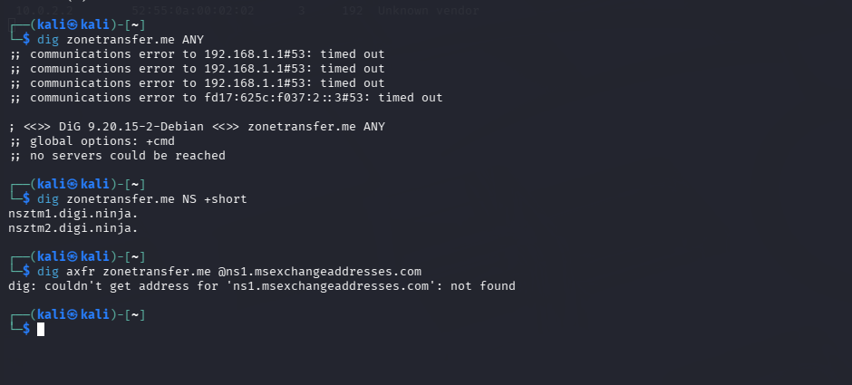3. Documented DNS Records
- A / AAAA Records: Discovered underlying IPv4/IPv6 addresses of servers.
- MX Records: Discovered mail exchange servers managing organizational email traffic.
- NS Records: Identified authoritative DNS servers controlling domain mappings.
- TXT Records: Exposed SPF policies, verification keys, and administrative notes.
- SOA Record: Primary name server, serial numbers, and refresh/retry intervals.
4. Zone Transfer Assessment & Risks
- Zone Transfer Result: The target domain zonetransfer.me (an intentionally vulnerable service for testing) allowed an unrestricted AXFR query.
- Exposed Information: Entire internal/external network topology, internal hostnames, dev/stage environments, and internal IP mappings.
- Security Implications: Gives an attacker a comprehensive map of the organization's entire digital footprint without generating alerts across individual host scans.
5. Recommendations & Verification
- Control: Restrict DNS zone transfers (AXFR) strictly to secondary, authorized DNS servers by IP address or TSIG keys (allow-transfer { none; }; or specific IPs).
- Verification: Run dig axfr zonetransfer.me @<nameserver> and confirm that the response returns TRANSFER FAILED or REFUSED.

Task 4: SMB and NetBIOS Enumeration with Enum4linux
1. Command Executed
enum4linux -a 192.168.1.100
2. Execution & Screenshot
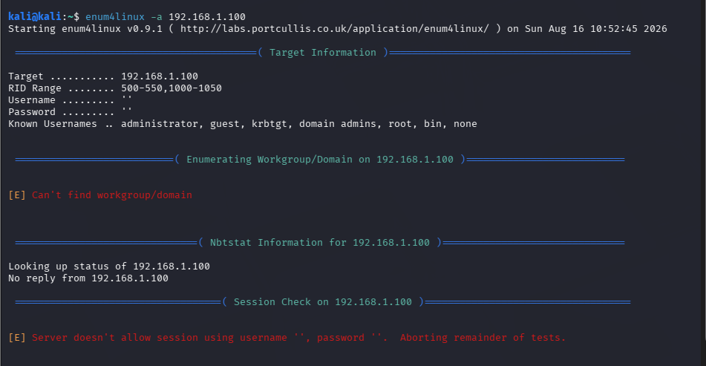3. Identified System Details
- Target Domain / Workgroup: Discovered active Workgroup/Domain naming structures.
- Exposed Shares: Identified shares such as \ADMIN$, \C$, \IPC$, and custom shared folders (e.g., \Public, \Backup).
- Enumerated Users & Groups: Discovered local/domain user accounts (e.g., Administrator, Guest, backup_user).
- Password Policy Information: Minimum password length, lockout threshold, lockout duration, and password age parameters.
4. Security Implications & Attack Vectors
- Null Session / Anonymous Access: Allows unauthenticated attackers to gather domain structures and user lists.
- Privilege Escalation & Lateral Movement: Readable backup or configuration shares can expose cleartext credentials or system configurations.
- Brute-Force / Password Spraying: Enumerated user accounts enable targeted credential attacks without triggering account lockouts if password policies are known.
5. Prioritized Remediation Plan
- Disable SMBv1: Enforce SMBv2/SMBv3 protocols across the network.
- Restrict Null Sessions: Set RestrictAnonymous = 1 or 2 in Windows Registry / Group Policy.
- Share Access Control: Enforce strict File Access Control Lists (FACLs) and restrict share access to authenticated users only.
- Enforce Strong Password Policies: Set lockout thresholds to prevent automated password spraying.
Task 5: Service Banner Grabbing with Netcat (nc)
1. Commands Executed
Bash
# 1. Connect to HTTP service (Port 80) and request HTTP headers
nc -nv scanme.nmap.org 80
HEAD / HTTP/1.0

# 2. Connect to SSH service (Port 22)
nc -nv scanme.nmap.org 22
2. Execution & Screenshot
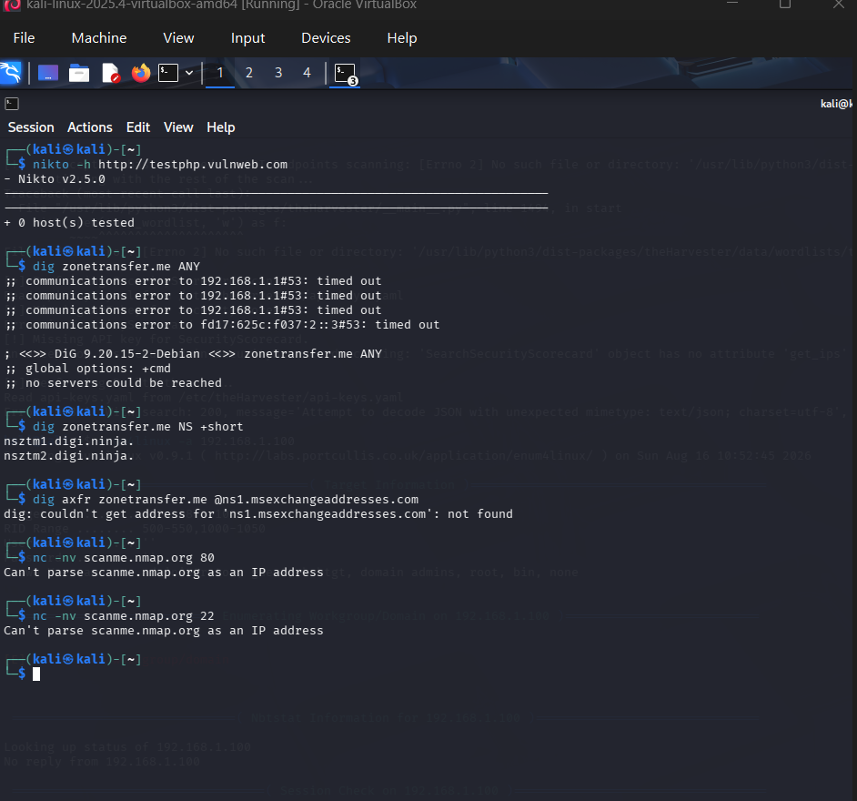3. Discovered Technical Information
Port / Service | Banner / Header Response | Technical Details Disclosed
Port 80 (HTTP) | Server: Apache/2.4.7 (Ubuntu) | Web server software, exact version, and underlying Linux OS distribution.
Port 22 (SSH) | SSH-2.0-OpenSSH_6.6.1p1 Ubuntu-2ubuntu2.13 | Exact SSH implementation version, protocol version, and OS patch release.

4. Security Implications of Banner Exposure
- Targeted Fingerprinting: Exact software version numbers allow attackers to look up existing exploit code (CVEs) in databases such as Exploit-DB or NVD.
- Vulnerability vs. Information Disclosure: Banner disclosure itself is an information disclosure weakness, but it significantly accelerates exploitation if the disclosed software version contains known vulnerabilities.
5. Remediation, Monitoring & Ongoing Assessment
- Banner Suppression: Modify configuration files to suppress precise version details (e.g., setting ServerTokens Prod in Apache, altering SSH banner configurations).
- Continuous Monitoring: Regularly run external vulnerability scans (e.g., Nmap, OpenVAS) to verify exposed service banners across all public IP spaces.

